EXPERIMENT-09
Working with Intents. Create an android application that uses both implicit and explicit intents to navigate between different activities. Implement intent filters for specific actions.
Aim: To create an Android application that uses Explicit and Implicit Intents to navigate between activities and implement Intent Filters.
Theory:
- What is an Intent?
An Intent is a messaging object used to request an action from another component in Android.
Intents are mainly used for:
- Starting another activity
- Opening system applications
- Passing data between activities

- Types of Intents
I. Explicit Intent
Explicit intent specifies the exact activity to start.
Example:
- Move from MainActivity → SecondActivity
II. Implicit Intent
Implicit intent does not specify the target activity. Android finds a suitable application to perform the action.
Example:
- Open browser
- Open dialer
- Share text

- Project Structure
- MainActivity
- SecondActivity
- activity_main.xml
- activity_second.xml
- AndroidManifest.xml

Code:
activity_main.xml
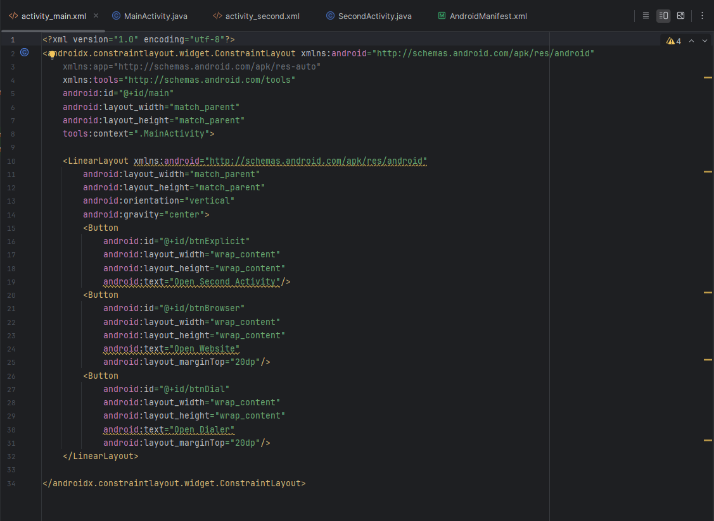
MainActivity.java
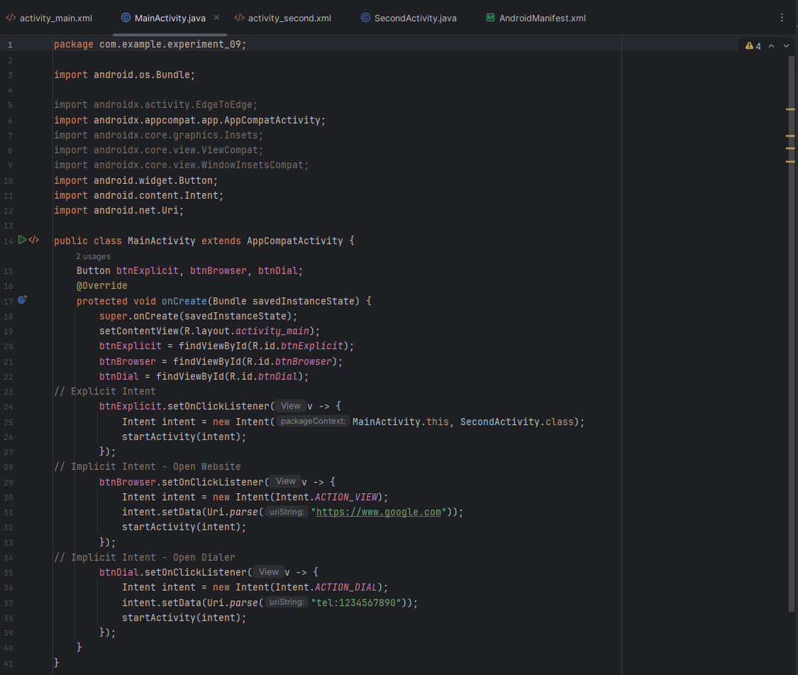
activity_second.xml
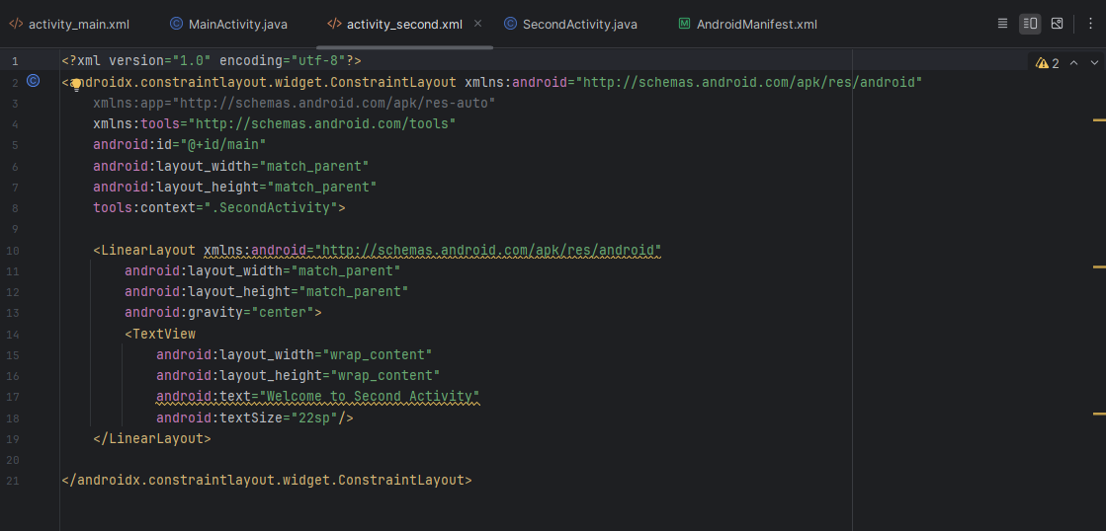
SecondActivity.java
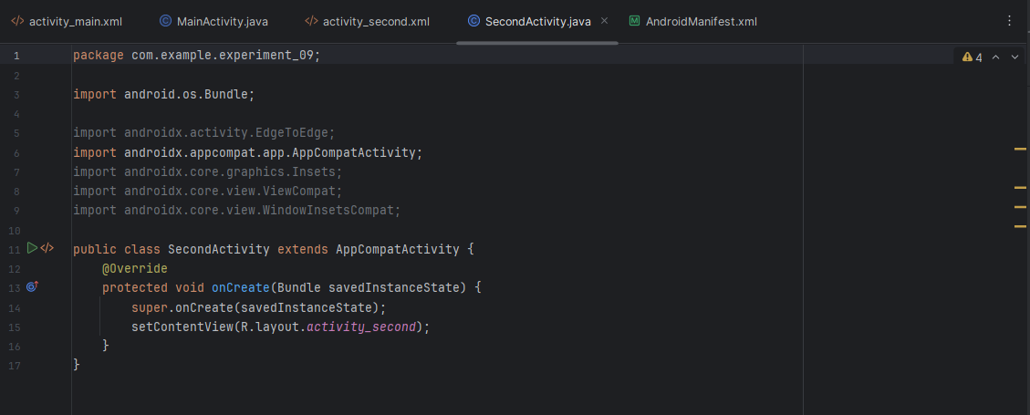

AndroidManifest.xml (Intent Filter)
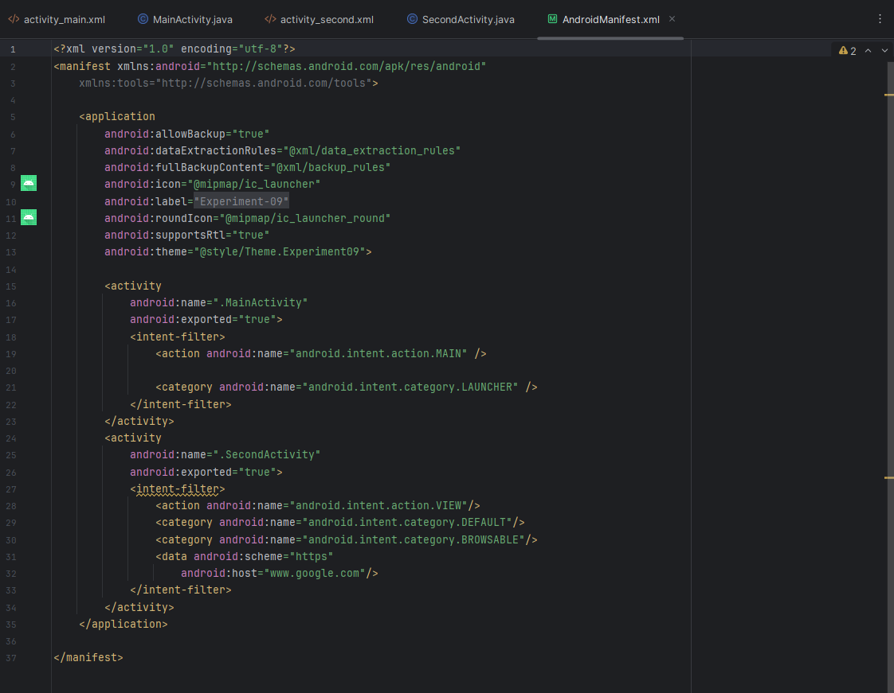
Output:
1) Explicit Intent
Button click: MainActivity → SecondActivity

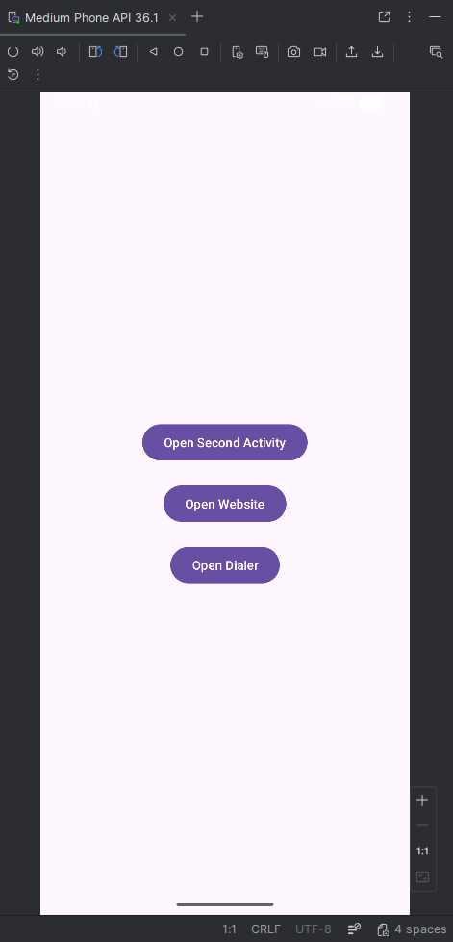 | 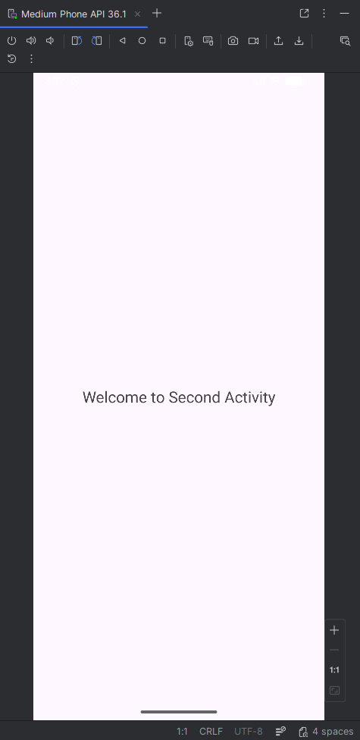
2) Implicit Intent (Browser)
Button click: Open Website → Browser opens google.com

 | 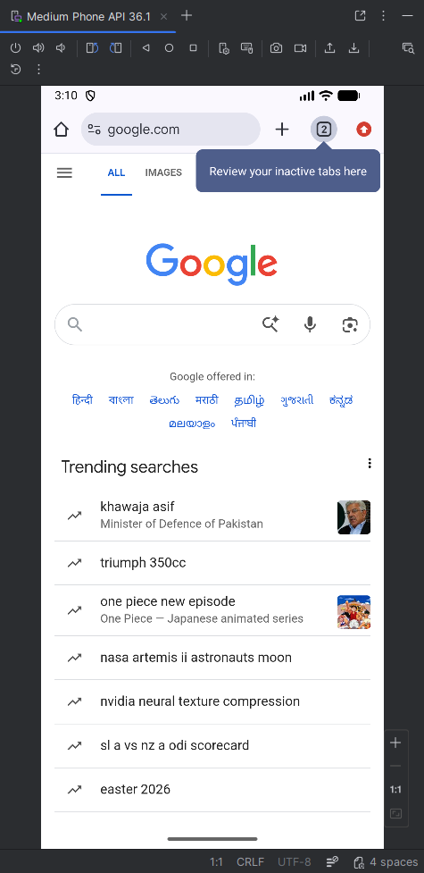

3) Implicit Intent (Dialer)
Button click: Dialer opens with number 1234567890

 | 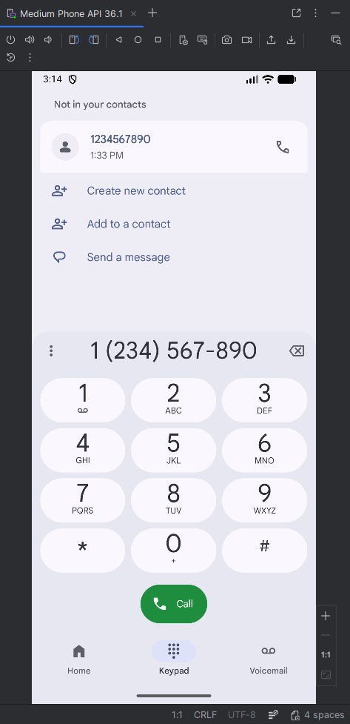

Conclusion:
This experiment demonstrated how Explicit Intents can be used to navigate between activities within the same application, while Implicit Intents enable interaction with external apps based on user actions. It also helped in understanding the role of Intent Filters in defining how activities respond to specific actions. Overall, the practical enhanced knowledge of Android component communication and activity management.

